**Chatellenaz M. et al. 2025. Records of short-tailed pumas in northeastern Argentina**

**82, 07- 09. Supporting Online Material**

|  |
| --- |
|  |
| **Fig. 1.** Location of the short-tailed puma records reported in this paper, along with other records in the Americas: **1)** Torres del Paine National Park, Chile; **2)** Vancouver, Canada; **3)** Cloudbridge Nature Reserve, Costa Rica; **4)** Establecimiento Las Marías, Argentina (Map M. L. Chatellenaz). |

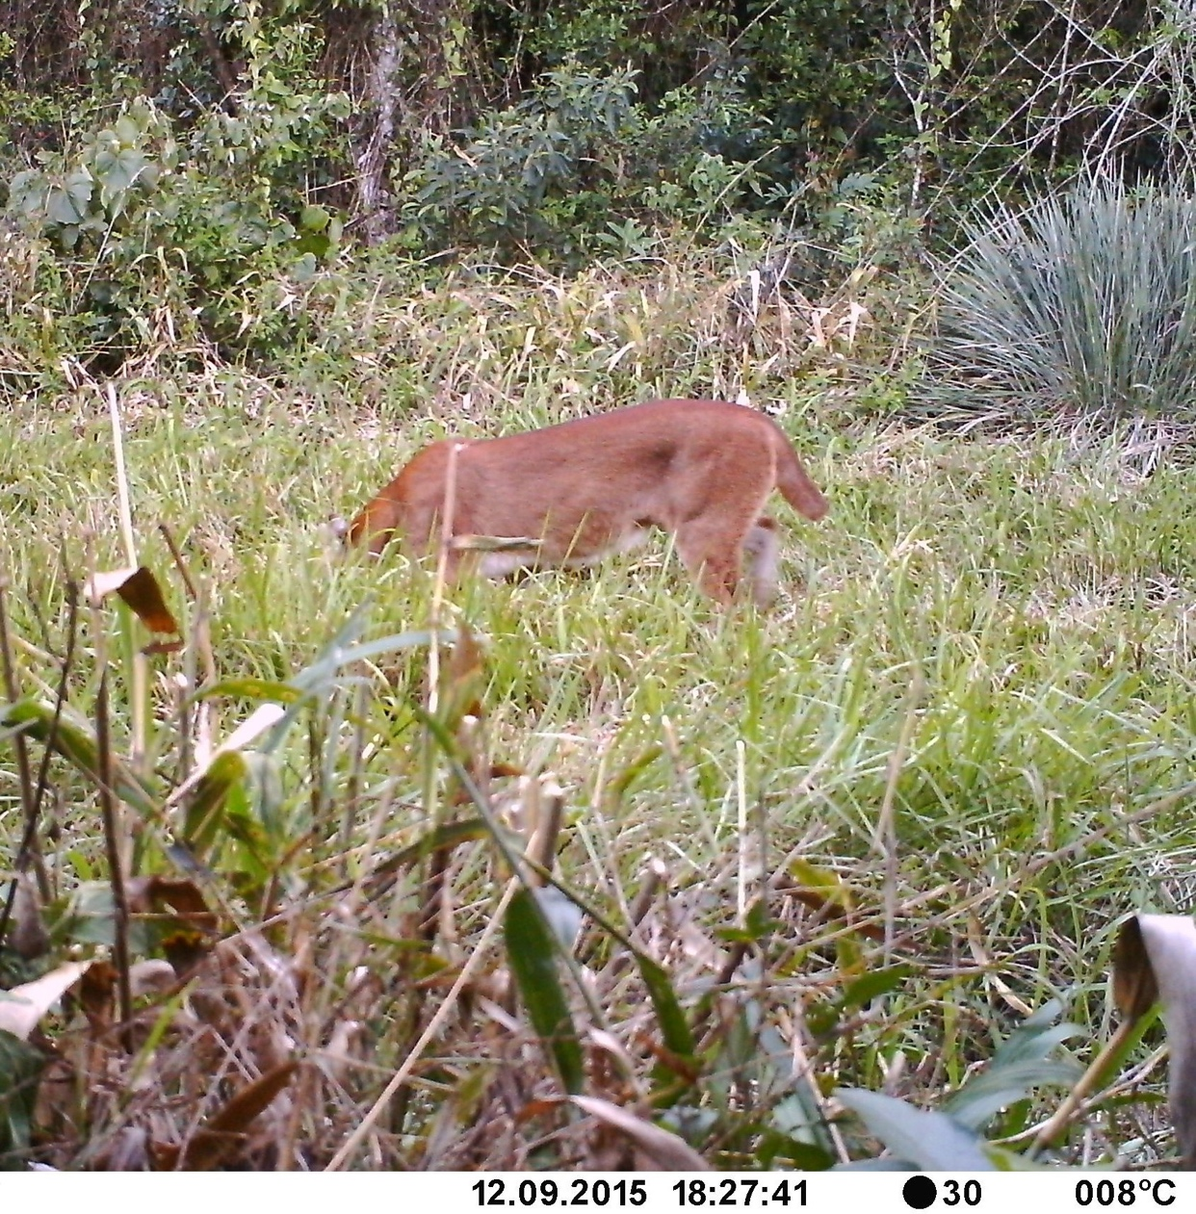

**Fig. 2.** First record of a short-tailed puma at the Establecimiento Las Marías (Corrientes, Argentina). It was a female, accompanied by a juvenile a few months old, as seen in another photograph taken moments later.